

For Sale

42 Hob Hill Close, Saltburn by the Sea

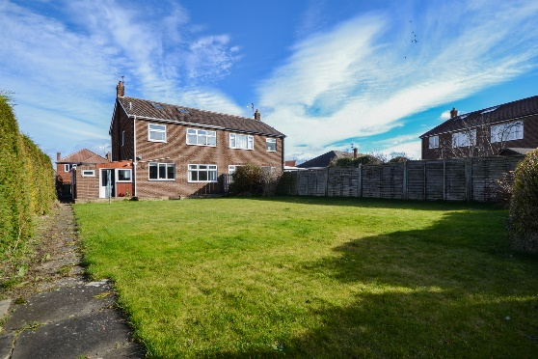

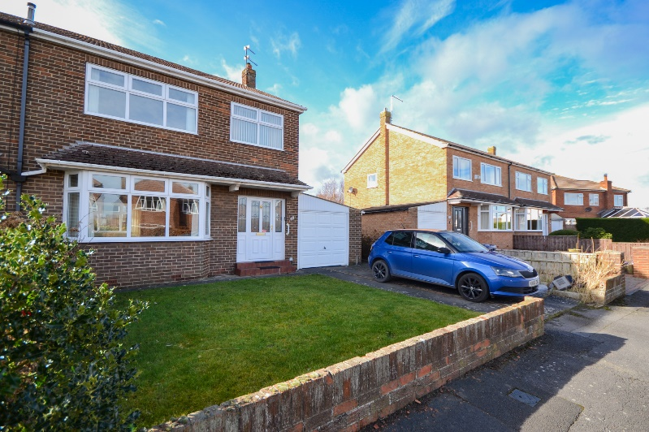

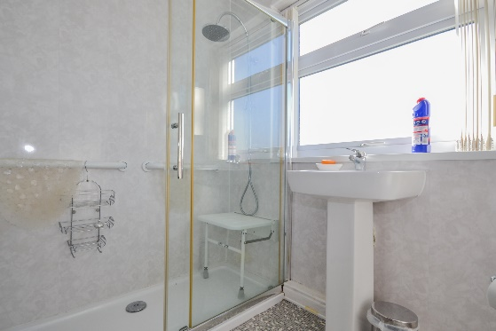

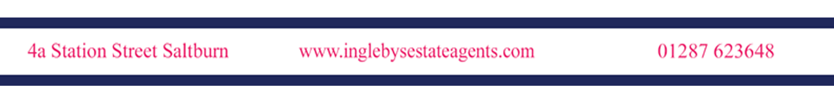

£295,000

REQUIRING MODERNISATION, A PERFECT OPPORTUNITY TO ACQUIRE A 3-BEDROOM SEMI-DETACHED FAMILY HOME WITH FRONT & REAR GARDENS AND OFF-STREET PARKING, SITUATED WITHIN PRIME SALTBURN LOCATION.

42 Hob Hill Close, Saltburn by the Sea
Situated within the ever-popular Hob Hill Close estate, within walking distance to Saltburn’s Golf Club, Leisure Centre and local school, the property benefits from a great-sized enclosed rear garden, and off-street parking to the front elevation via driveway & single garage. In need of cosmetic upgrades, and deceptively spacious throughout, the property will make an excellent family home.
The property briefly comprises:
Entrance Hall
UPVC double glazed door & side panels to the front aspect. Radiator. Stairs leading to the first floor. Under-stairs storage cupboard.

Living Room (5.06m x 4.15m)
UPVC double glazed bay window to the front aspect. Radiator. Feature fireplace. Coving. Double doors open to the Dining Room.

Dining Room (3.55m x 3.22m)
UPVC double glazed window to the rear aspect. Radiator. Coving.

Kitchen (3.37m x 2.89m)
A range of wall, base & drawer units. Laminate worktops incorporating stainless steel sink with single drainer & mixer tap. Integrated eye-level double oven & separate electric hob. UPVC double glazed window to the rear aspect overlooking the rear garden. Access to the Utility.

Utility
Courtesy door to the garage. Plumbing for washing machine & space for dryer. Access to ground-floor W/C. Wooden door opens to the Rear Garden.

First Floor

Landing
UPVC double glazed window to the side aspect. Loft hatch.

Bedroom One (4.24m x 3.76m)
UPVC double glazed window to the front aspect. Fitted wardrobes. Radiator.

Bedroom Two (3.76m x 3.37m)
UPVC double glazed window to the rear aspect. Radiator. Fitted wardrobes.

Bedroom Three (3.13m x 2.38m)
UPVC double glazed window to the front aspect. Radiator.
42 Hob Hill Close, Saltburn by the Sea

Bathroom (2.39m x 1.82m)
Walk-in shower cubicle. Pedestal hand basin. Low-level W/C. Part-cladded walls. UPVC double glazed window to the rear aspect.

External

Front Elevation
Garden area laid to lawn with established borders. Single driveway leading to single garage with ‘Up & Over’ door providing off-street parking for 2x cars. Pathway leads to the Rear Elevation.

Rear Elevation
A large enclosed garden, laid to lawn with a variety of shrubs. Greenhouse & garden shed. Additional block-paved patio area.

TENURE: FREEHOLD

MEASUREMENTS: Please note that all measurements contained in these particulars are for guidance purposes only and should not be relied upon for ordering carpets, furniture, etc. Anyone requiring more accurate measurements may do so by arrangement with our office.

SERVICES: Our description of any appliances and / or services (including any central heating system, alarm systems, etc.) should not be taken as any guarantee that these are in working order. The buyer is therefore advised to obtain verification from their solicitor, surveyor or other qualified person to check the appliances / services before entering into any commitment.

REF NO: SB866A

