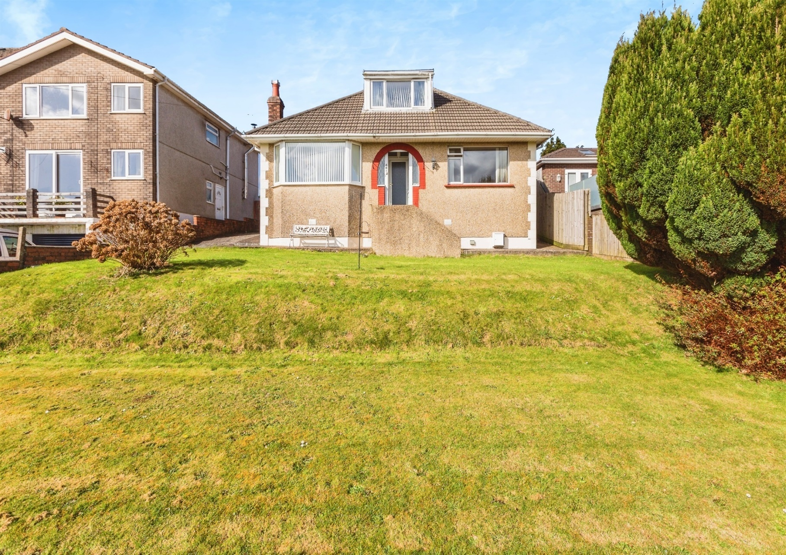
Trewyddfa Road, ##Invalid Field Name##
guide price £200,000
- Sale by Modern Auction (T&Cs apply)
- Subject to an undisclosed Reserve Price
- Buyers fees apply
- No Ongoing Chain
- Flexible Living Space
- Off Road Parking & Garage
- Conservatory
- Outsiding Swansea Vale Views
- EPC Rating: D
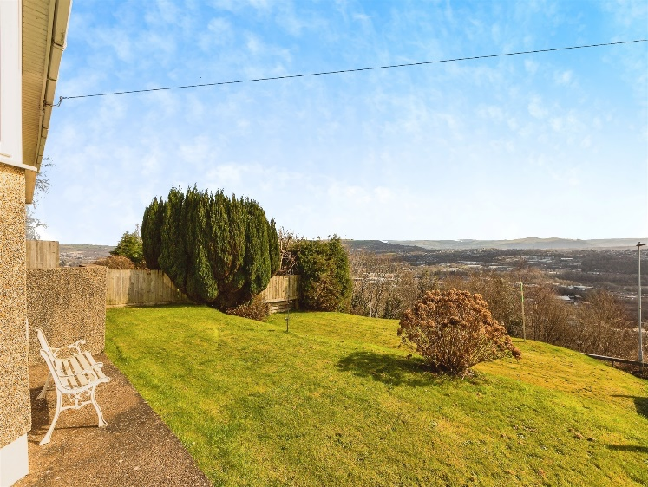

 |  | 3 |  | 1 |  | 2

01792 798201
morriston@peteralan.co.uk

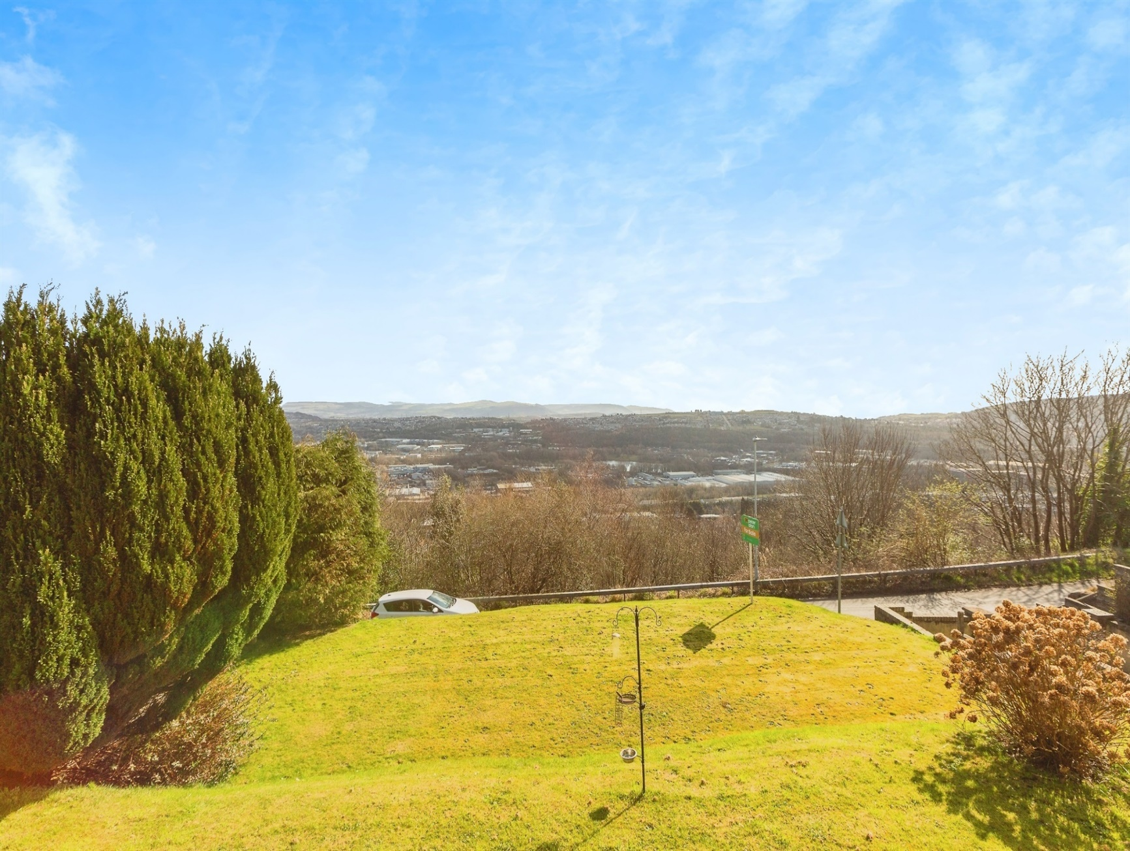
About the property

Situated in an elevated position with breathtaking views over Morriston and the Swansea Valley, this generously sized 2-3 bedroom detached dormer bungalow offers a fantastic opportunity for those looking to downsize without compromising on space or for families seeking a well-connected home.

The property is beautifully presented and in good condition throughout, featuring 2-3 versatile reception rooms, offering flexible living arrangements to suit your needs. To the rear, a large garage provides excellent storage or workshop potential, while additional off-road parking ensures convenience for multiple vehicles.

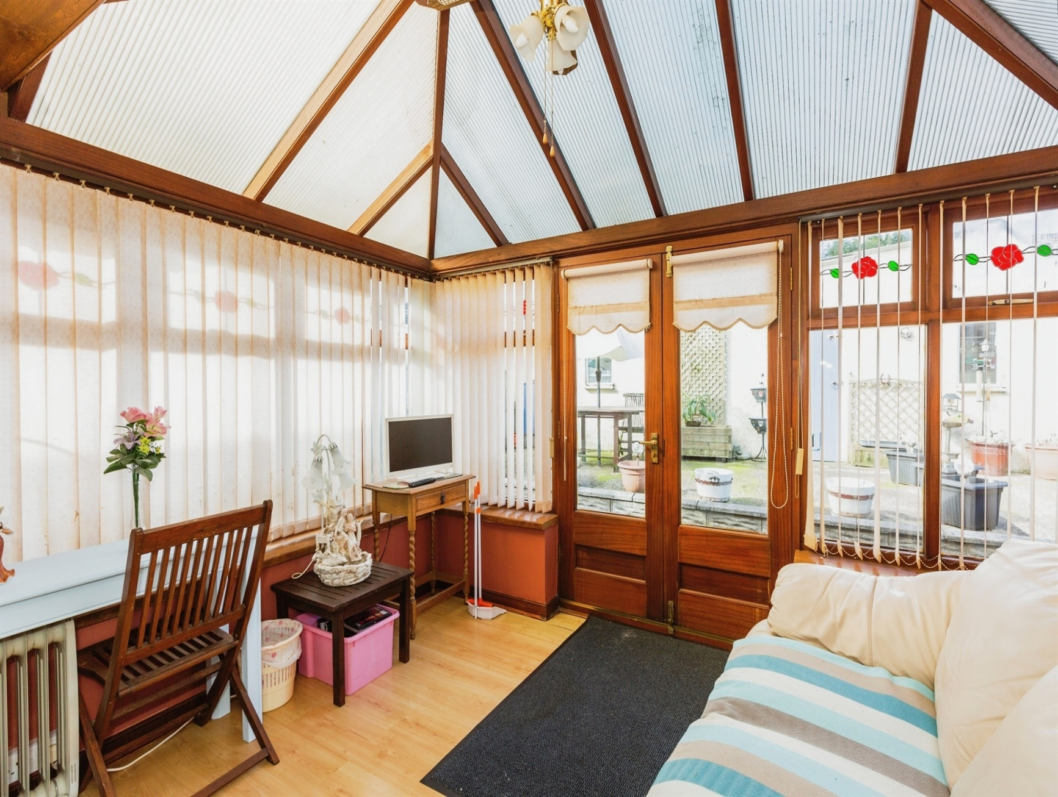
Accommodation

Auctioneer's Comments

This property is offered through Modern Method of Auction. Should you view, offer or bid your data will be shared with the Auctioneer, iamsold Limited. This method requires both parties to complete the transaction within 56 days, allowing buyers to proceed with mortgage finance (subject to lending criteria, affordability and survey).

The buyer is required to sign a reservation agreement and make payment of a non-refundable Reservation Fee of 4.5% of the purchase price including VAT, subject to a minimum of £6600.00 including VAT. This fee is paid in addition to purchase price and will be considered as part of the chargeable consideration for the property in the calculation for stamp duty liability. Buyers will be required to complete an identification process with iamsold and provide proof of how the purchase would be funded.

The property has a Buyer Information Pack containing documents about the property. The documents may not tell you everything you need to know, so you must complete your own due diligence before bidding. A sample of the Reservation Agreement and terms and conditions are contained within this pack. The buyer will also make payment of no more than £349 inc. VAT towards the preparation cost of the pack. Please confirm exact costs with the auctioneer.

The estate agent and auctioneer may recommend the services of other providers to you, in which they will be paid for the referral. These services are optional, and you will be advised of any payment, in writing before any services are accepted. Listing is subject to a start price and undisclosed reserve price that can change.

Entarnace Hall

Lounge

12' Max x 14' 7" ( 3.66m Max x 4.45m )
Conservatory

11' 6" x 8' 3" ( 3.51m x 2.51m )
Kitchen

10' 2" x 9' 2" ( 3.10m x 2.79m )
Utility Room

11' 8" x 7' 3" ( 3.56m x 2.21m )
Bedroom One

21' 3" Max x 15' 8" Max ( 6.48m Max x 4.78m Max )
Bedroom Two

12' x 11' 8" ( 3.66m x 3.56m )
Living Room/Bedroom Three

12' x 13' 1" ( 3.66m x 3.99m )
Bathroom

Garage

16' 5" x 21' 3" ( 5.00m x 6.48m )

01792 798201
morriston@peteralan.co.uk
Floorplan

Important Information
Note while we endeavour to make our sales details accurate and reliable, if there is any point which is of particular interest to you, please contact the office and we will be pleased to confirm the position for you. We have not personally tested any apparatus, equipment, fixtures, fittings or services and cannot verify they are in working order or fit for their purposes. Nothing in these particulars is intended to indicate that carpets or curtains, furnishings or fittings, electrical goods (whether wired or not). Gas fires or light fitments or any other fixtures not expressly included form part of the property offered for sale. This computer generated Floorplan, if applicable, is intended as a general guide to the layout and design of the property. It is not to scale and should not be relied upon for dimensions. Tenure: We cannot confirm the tenure of the property as we have not had access to the legal documents. The buyer is advised to obtain verification from their solicitor or surveyor.
Peter Alan Limited is registered in England and Wales under company number 2073153, Registered Office is Cumbria House, 16-20 Hockliffe Street, Leighton Buzzard, Bedfordshire, LU7 1GN. VAT Registration Number is 500 2481 05. For activities relating to regulated mortgages and non-investment insurance contracts, Peter Alan Limited is an appointed representative of Connells Limited which is authorised and regulated by the Financial Conduct Authority. Connells Limited’s Financial Services Register number is 302221. Most buy-to-let mortgages are not regulated.




