Burnside,Thurnscoe Rotherham S63 0PW

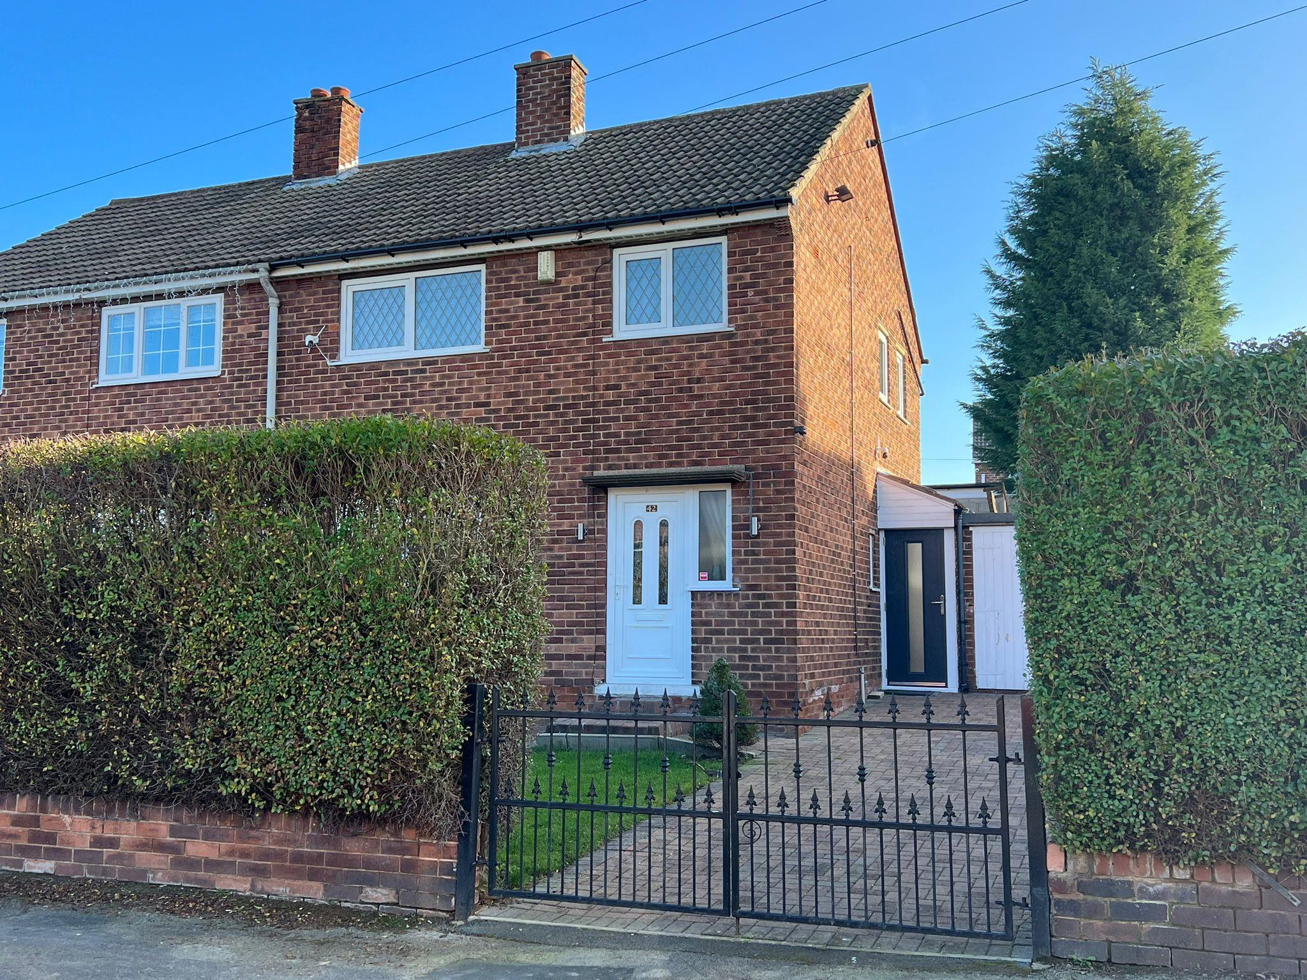
Ground Floor:
Entrance Hallway
The entrance hallway comprises of a UPVC double glazed entrance door to the front and stairs leading to the first floor accommodation.

Lounge
A spacious living & family area, which presents a central heating radiator and a UPVC double glazed window to the front.

Dining Room
A well-presented dining room, which has a UPVC double glazed window to the rear and a central heating radiator.

Kitchen
A delightful kitchen area, which is presented with a range of wall and base units, work surfaces and an inset sink and drainer unit. Having space for a cooker, plumbing for a washing machine, a pantry, a central heating radiator and a UPVC double glazed window to the rear and a door to the side.

1st Floor:
Landing
Presented with a side facing UPVC double glazed window and a storage cupboard.

Bedroom One
A rear facing bedroom, which comprises of a central heating radiator and a UPVC double glazed window to the rear.

Bedroom Two
Bedroom two has a front facing UPVC double glazed window and a central heating radiator.

Bedroom Three
A front facing bedroom, which is presented with a storage cupboard, a UPVC double glazed window to the front and a bulk head.

Bathroom
A stylish suite, which comprises of a corner bath, a W/C & hand wash basin, a central heating radiator and two UPVC double glazed windows (one to the rear & one to the side).

Exterior:
To the front of the property lays a delightful & well-presented lawned garden benefiting from a driveway for off street vehicle parking and having double gates to enclose.

To the rear lays another well-maintained lawned garden- a perfect outside place for guest & family entertainment!

welcome to‍ ‍
Burnside, Thurnscoe Rotherham
FIND YOUR SPARK AT BURNSIDE! A 3-bed semi-detached home in a popular location, close proximity to amenities & Thurnscoe train station. Offering a driveway, generous front & rear gardens & spacious accommodation - an excellent family home or investment/ buy-to-let opportunity. CALL NOW!


 | 01709 583267
 | mexborough@williamhbrown.co.uk
 | 4 Main Street, MEXBOROUGH, South Yorkshire, S64 9DW
 | williamhbrown.co.uk
welcome to
Burnside,
Thurnscoe Rotherham
- 3 bed semi detached home. EPC C. Council Tax A
- Popular location - well placed for local amenities & Thurnscoe train station
- Spacious throughout - 2 reception rooms
- Driveway providing off street parking!
- Plentiful lawned gardens to the front & rear!

Tenure: Freehold‍ ‍EPC Rating: C
Council Tax Band: A

‍‍
£140,000

Property Ref:
MXB119556 - 0003

view this property online ‍ ‍williamhbrown.co.uk/Property/MXB119556
1. MONEY LAUNDERING REGULATIONS Intending purchasers will be asked to produce identification documentation at a later stage and we would ask for your co-operation in order that there is no delay in agreeing the sale. 2. These particulars do not constitute part or all of an offer or contract. 3. The measurements indicated are supplied for guidance only and as such must be considered incorrect. Potential buyers are advised to recheck measurements before committing to any expense. 4. We have not tested any apparatus, equipment, fixtures or services and it is in the buyers interest to check the working condition of any appliances. 5. Where an EPC, or a Home Report (Scotland only) is held for this property, it is available for inspection at the branch by appointment. If you require a printed version of a Home Report, you will need to pay a reasonable production charge reflecting printing and other costs. 6. We are not able to offer an opinion either written or verbal on the content of these reports and this must be obtained from your legal representative. 7. Whilst we take care in preparing these reports, a buyer should ensure that his/her legal representative confirms as soon as possible all matters relating to title including the extent and boundaries of the property and other important matters before exchange of contracts.
William H Brown is a trading name of Sequence (UK) Limited which is registered in England and Wales under company number 4268443, Registered Office is Cumbria House, 16-20 Hockliffe Street, Leighton Buzzard, Bedfordshire, LU7 1GN. VAT Registration Number is 500 2481 05.

