For Sale

12 Staithes Lane, Staithes

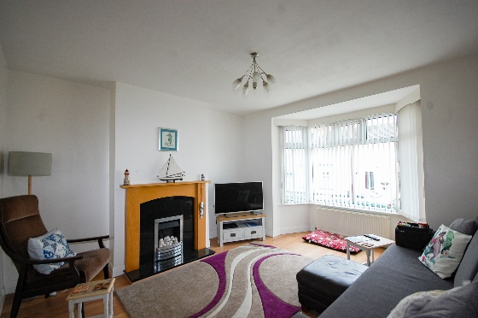

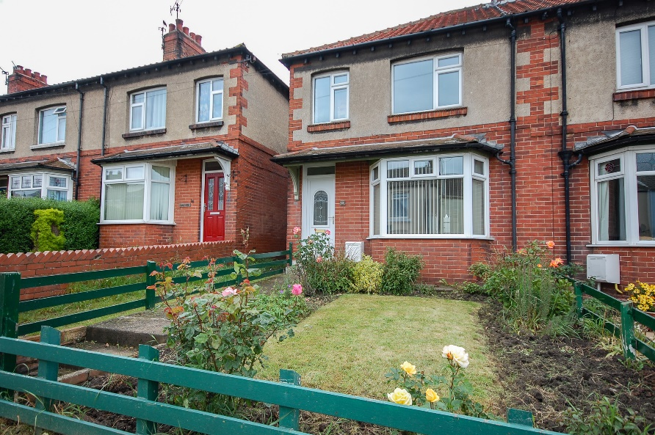

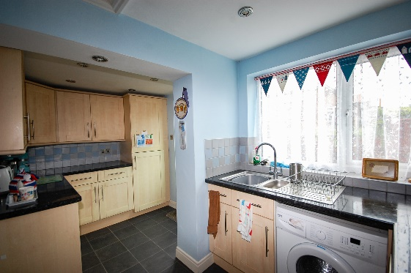

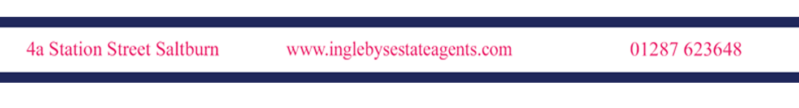

£171,500

A SPACIOUS 3 BEDROOM END OF TERRACE RESIDENCE IN THE POPULAR FISHING VILLAGE OF STAITHES WITH A GARDEN TO THE FRONT & A LOW MAINTENANCE ENCLOSED COURTYARD TO THE REAR, A PERFECT HOLIDAY HOME OR PERMANENT RESIDENCE CLOSE TO ALL LOCAL AMENITIES

12 Staithes Lane, Staithes

The property benefits from gas central heating, uPVC double glazed windows, fitted kitchen with a range of appliances, small front garden, rear courtyard & on-street parking with residence permit

The accommodation comprises of;

Living Room 12’5 x 14’4
uPVC double glazed bay window, feature fireplace incorporated into wooden surround, French doors with access to dining room, radiator

Dining Room 12’11 x 11’10
French doors with access to kitchen, large under-stairs storage cupboard, radiator

Kitchen 13’9 x 7’4
uPVC double glazed window, range of wall, base & drawer units, laminate worktops, part tiled, stainless steel inset sink unit with mixer tap, electric oven & hob, extractor unit, under-counter integrated fridge & freezer, plumbing for automatic washing machine, cupboard housing boiler, uPVC door

First Floor

Landing
Loft access with retractable ladder, fully boarded power & light

Bathroom 6’2 x 7’8
uPVC double glazed window, tiled, low-level w/c, pedestal wash hand basin, panel bath, mixer shower over running off gas boiler, radiator

Master 11’11 x 10’4
uPVC double glazed window, T.V. point, radiator

Bedroom 2 10’6 x 11’9
uPVC double glazed window, T.V. point, radiator

Bedroom 3 11’7 x 5’6
uPVC double glazed window, radiator

External

Front
Small garden

Rear
Courtyard

12 Staithes Lane, Staithes

TENURE: FREEHOLD

MEASUREMENTS: Please note that all measurements contained in these particulars are for guidance purposes only and should not be relied upon for ordering carpets, furniture, etc. Anyone requiring more accurate measurements may do so by arrangement with our office.

SERVICES: Our description of any appliances and / or services (including any central heating system, alarm systems, etc.) should not be taken as any guarantee that these are in working order. The buyer is therefore advised to obtain verification from their solicitor, surveyor or other qualified person to check the appliances / services before entering into any commitment.

REF NO: SKE271A

